**Ideation Phase**

**Define the Problem Statements**

|  |  |
| --- | --- |
| Date | 19 September 2022 |
| Team ID | PNT2022TMIDxxxxxx |
| Project Name | Project - xxx |
| Maximum Marks | 2 Marks |

**Customer Problem Statement Template:**

Create a problem statement to understand your customer's point of view. The Customer Problem Statement template helps you focus on what matters to create experiences people will love.

A well-articulated customer problem statement allows you and your team to find the ideal solution for the challenges your customers face. Throughout the process, you’ll also be able to empathize with your customers, which helps you better understand how they perceive your product or service.

|  |  |  |
| --- | --- | --- |
| **I am** | Describe customer with  3-4 key characteristics –  Who are they? | The customers may be the companies which are dependent on water as their primary resource and people who are going to consume the water |
| **I’m trying to** | List their outcome or “job” the care about – what are they trying to achieve? | To get clear water from the water resources |
| **but** | Describe what problems or barriers stand in the way – what bothers them most? | The water which is present in those water bodies are contaminated by the chemical fertilizers which are being used in the farm lands by farmers and polluted by the rapid growth of algae |
| **because** | Enter the “root cause” of why the problem or barrier exists – what needs to be solved? | The root cause of this problem is use of chemical fertilizers |
| **which makes me feel** | Describe the emotions from the customer’s point of view – how does it impact them emotionally? | Sad worried and depressed |

**Example:**

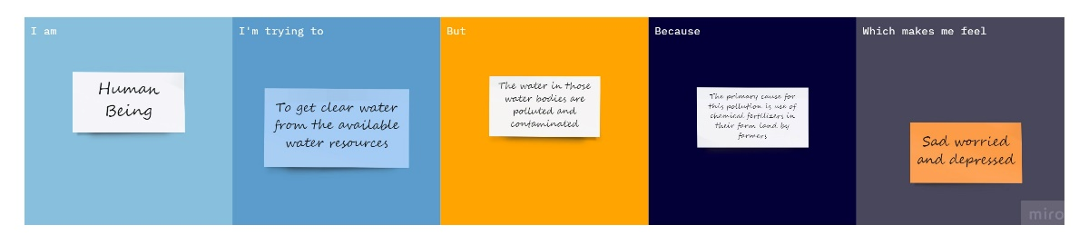

|  |  |  |  |  |  |
| --- | --- | --- | --- | --- | --- |
| **Problem Statement (PS)** | **I am (Customer)** | **I’m trying to** | **But** | **Because** | **Which makes me feel** |
| PS-1 | Human | To get clear water | The water bodies are polluted and contaminated | It is because of using chemical fertilizers in farm land by farmers and by algal bloom | Sad, worried, depressed and frustrated |
| PS-2 | Company | To get clear water | The water bodies are polluted and contaminated | It is because of using chemical fertilizers in farm land by farmers and by algal bloom | Sad, worried, depressed and frustrated |